Aim: - Perform the NMAP AND NETCAT SCAN COMMANDS using Kali Linux.

Software Required: -

Kali Linux, Metaspoitable

Outputs: -

nmap -h

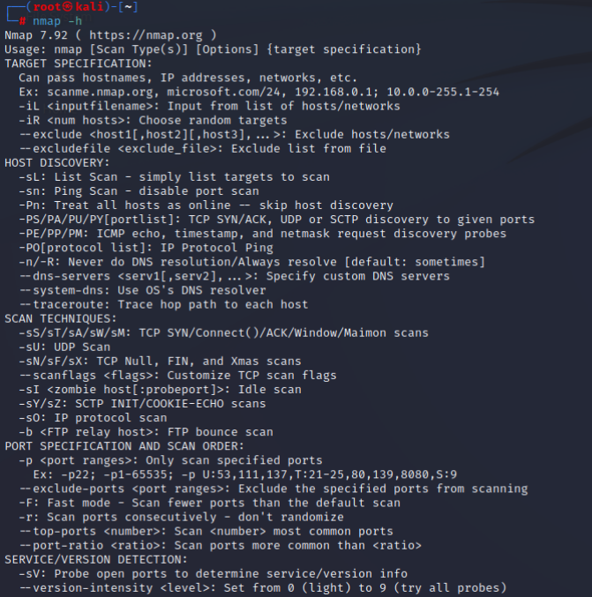

nmap -V

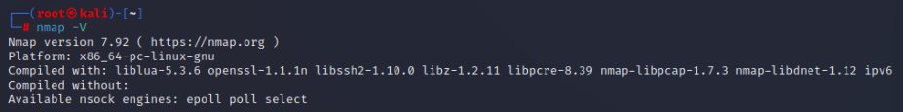

nmap scanme.nmap.org

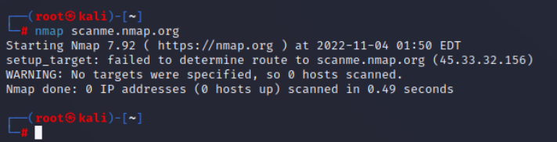

nmap scanme.nmap.org -A

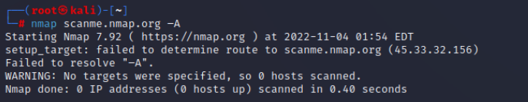

nmap scanme.nmap.org –sV

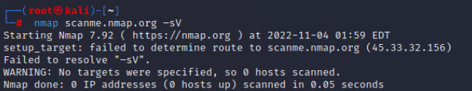

nmap scanme.nmap.org google.com –sn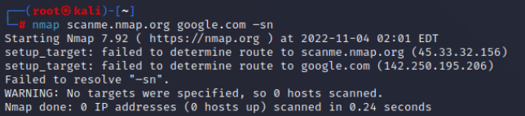

nmap scanme.nmap.org/24 –sn

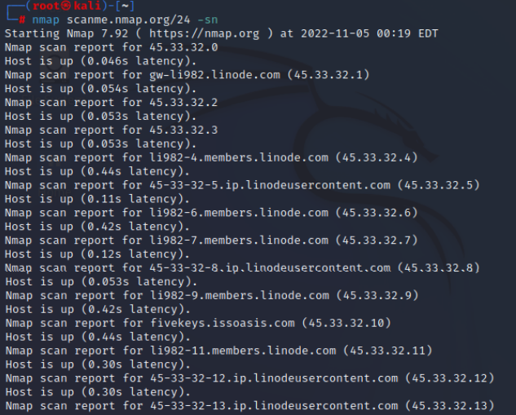

nmap google.com/24 –sn

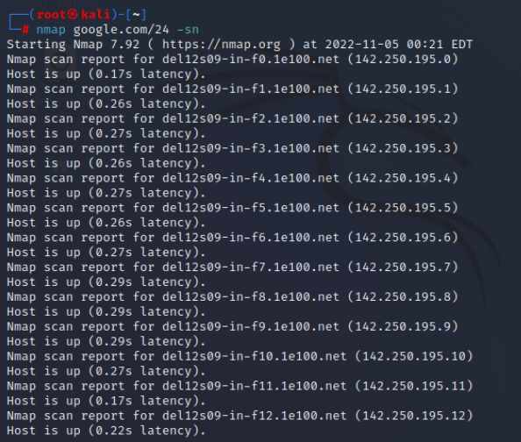

create nano list.txt 192.168.166.255 google.com   
nmap.org scanme.nmap.org

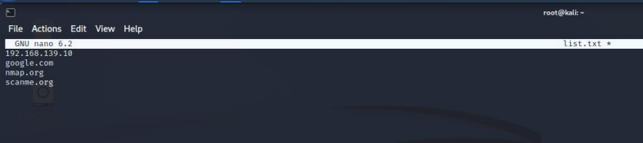

nmap –iL list.txt –sn

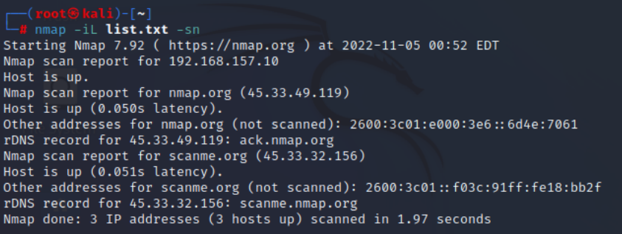

nmap –iL list.txt –sn --exclude google.com

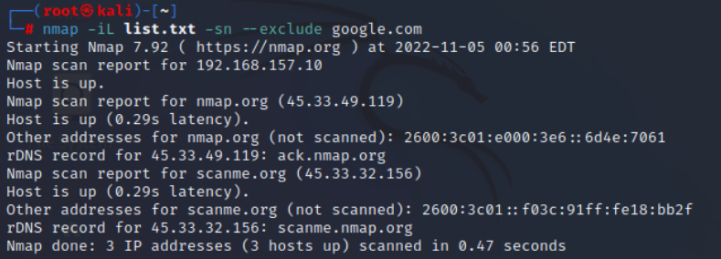

nmap 172.217.166.1-255 -sn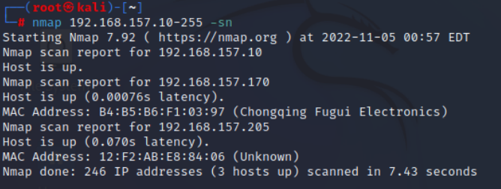

nmap 172.217.166.1-255 –sn - -exclude google.com

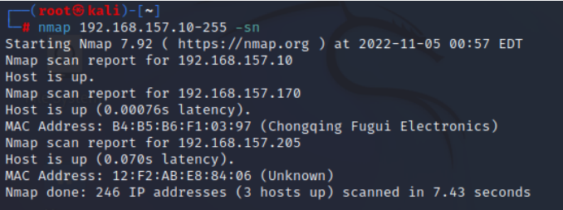

nmap 172.217.166.1-255 –sn - -excludefile list.txt

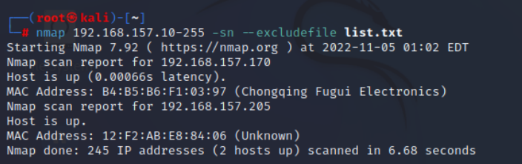

nmap scanme.nmap.org -F

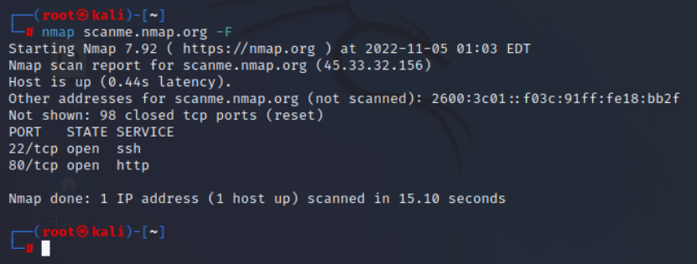

nmap scanme.org –p 1-100

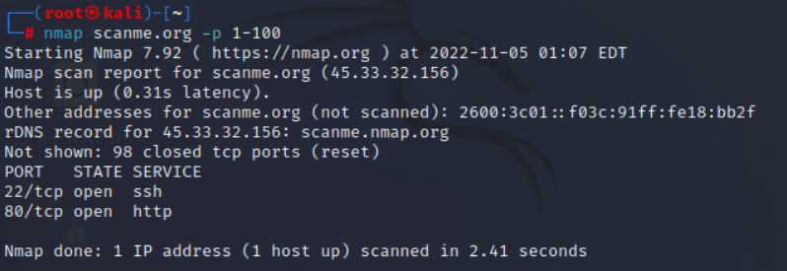

nmap –p T:500 google.com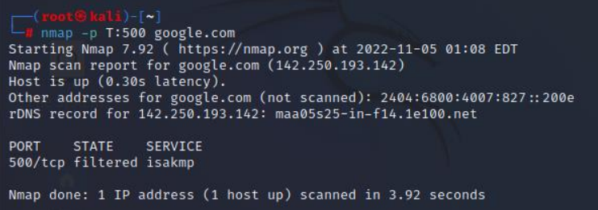

nmap - -top –ports 100 scanme.nmap.org

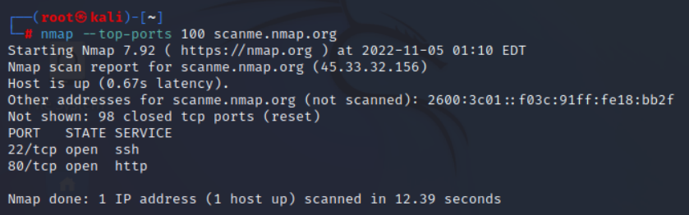

nmap -r scanme.nmap.org

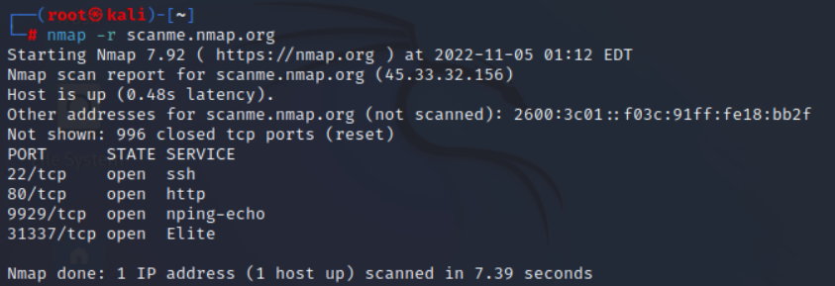

sudo apt-get install netcat

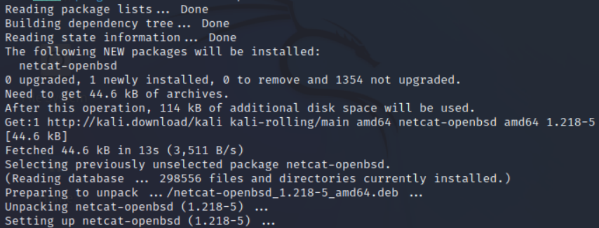

nc –h or netcat –h

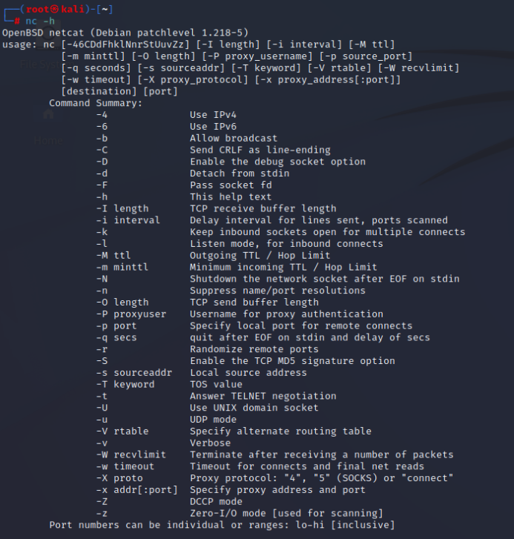

Result: -

Successfully created Malware File and detected it using Kali Linux